1st Edenvale Scout Group Land Logbook – Team 43





List of Members Camping

Zoe Pierce – PL
Michael van Esch – APL
Alexia Pantazis – Quarter Master
Grant Henley – Member
Zoe Govender – Member
Nqaba Ndlovu – Member
Oliver Muller – Member
Aiden Jacobs – Member
Jordon Alberts – Member
James Grobler – Member
Ethan Venter – Member

Programs

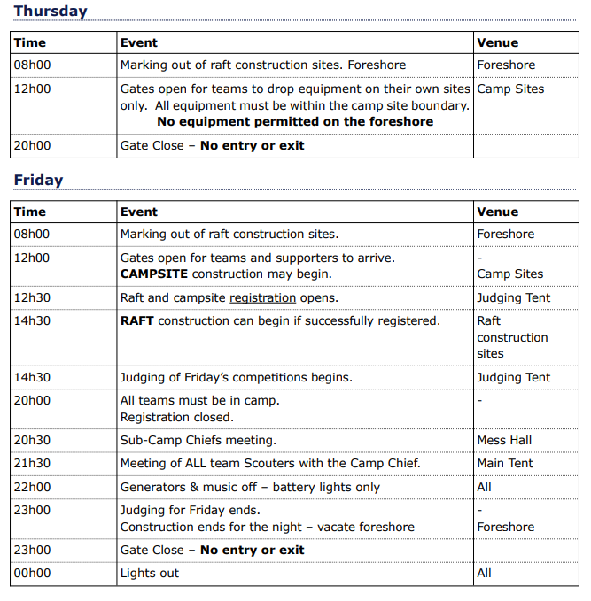
Kontiki Official Program

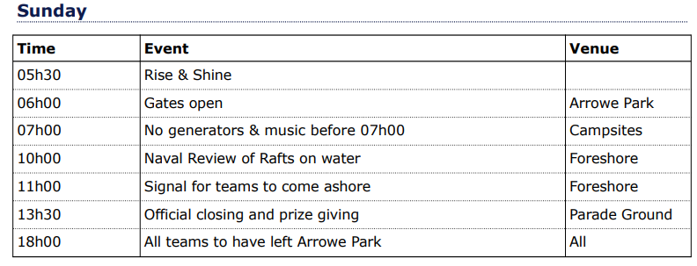
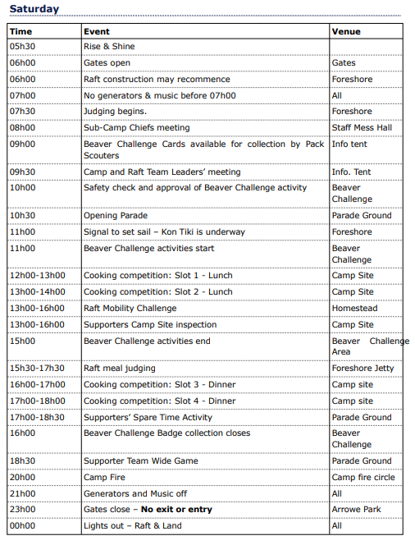
Kontiki Competition Timetable

FRIDAY
14h30 – 20h00 Raft Equipment Inspection - Raft construction site
14h00 - 21h00 Supporters Camp Site Safety Inspection - Supporters Camp
17h00 - 20h00 Base Inspection Raft construction site
19h00 - 21h00 Safety Interview & First Aid Kits Medical Services area
19h00 - 21h00 Model Raft Info Tent
20h00 - 23h00 Raft before decorations Raft construction site

SATURDAY
08h00 Pre-Launch Raft construction site
08h00 – 11h00 Raft final inspection Raft construction site
12h00 – 16h00 Beaver Challenge Beaver Challenge Area
12h00 - 13h00 Supports Meal Judging – Option 1 Camp site
13h00 - 14h00 Supports Meal Judging – Option 2 Camp site
14h30 - Raft launch deadline Raft construction site
13h00 - 15h00 Raft Mobility On water
13h30 – 17h00 Supporters Camp Site inspection Supporters Camp Site
15h30 - 17h30 Raft Meal judging The Bay / Foreshore
16h00 - 17h00 Supports Meal Judging – Option 3 Camp site
17h00 - 18h00 Supports Meal Judging – Option 4 Camp site
18h00 - 18h30 Supporters’ Spare Time Activity Parade Ground

Kontiki Program

1st Edenvale Supporters Scout Advancement Program
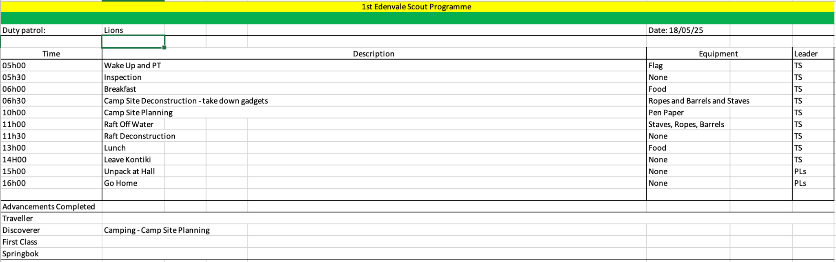
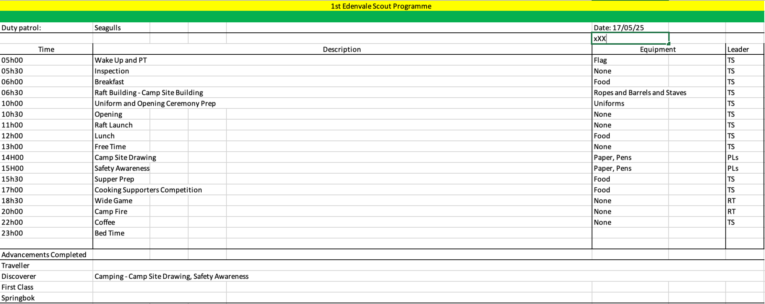
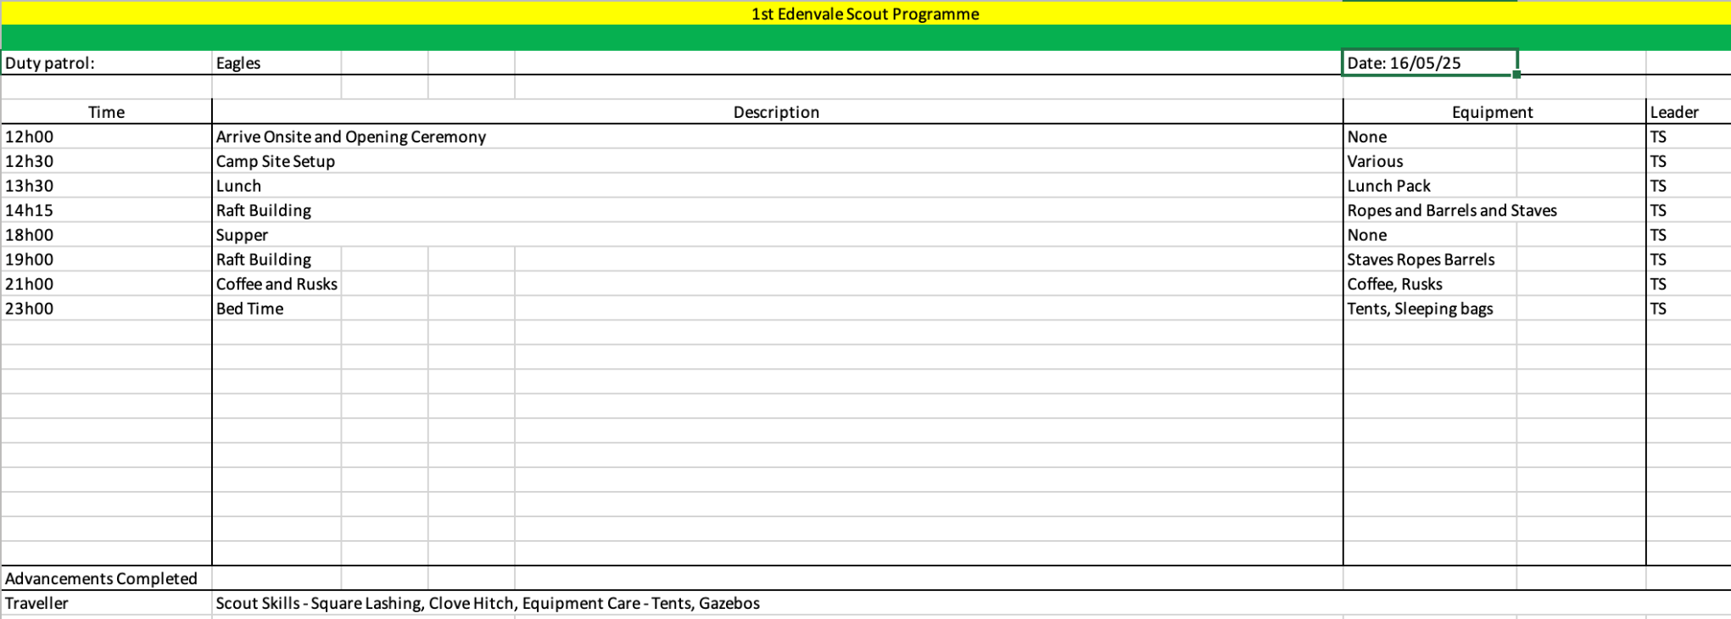

Campsite Planning

Gadget Drawings

Table - Side View
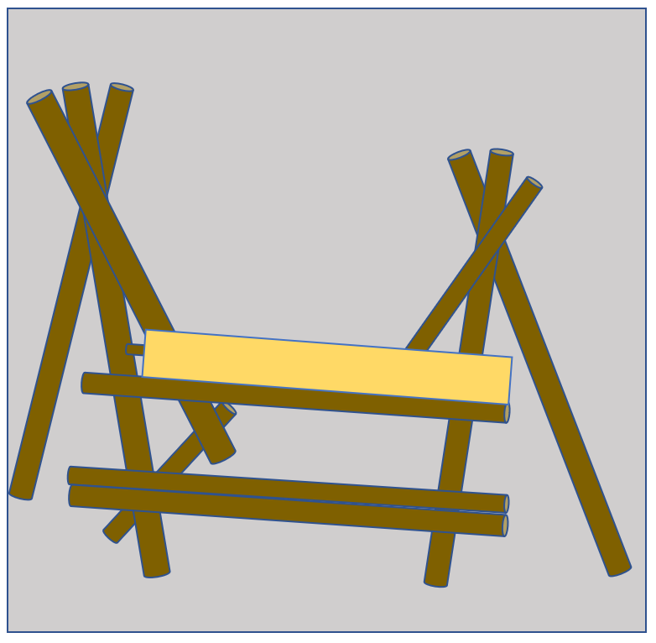

Table - Top View
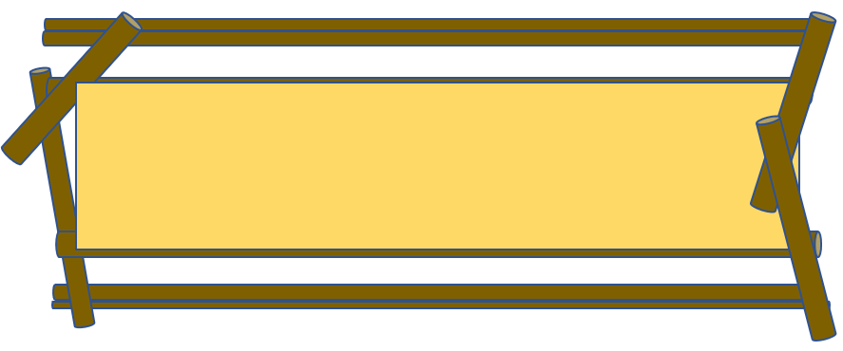

Dustbin - Side View Dustbin - Top View
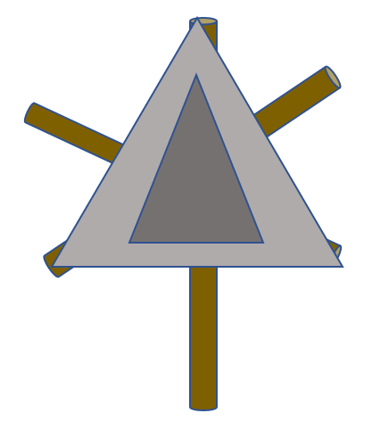
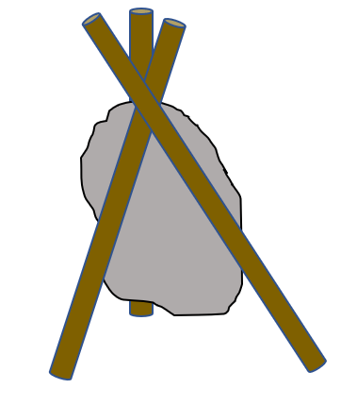

Gateway - Side View
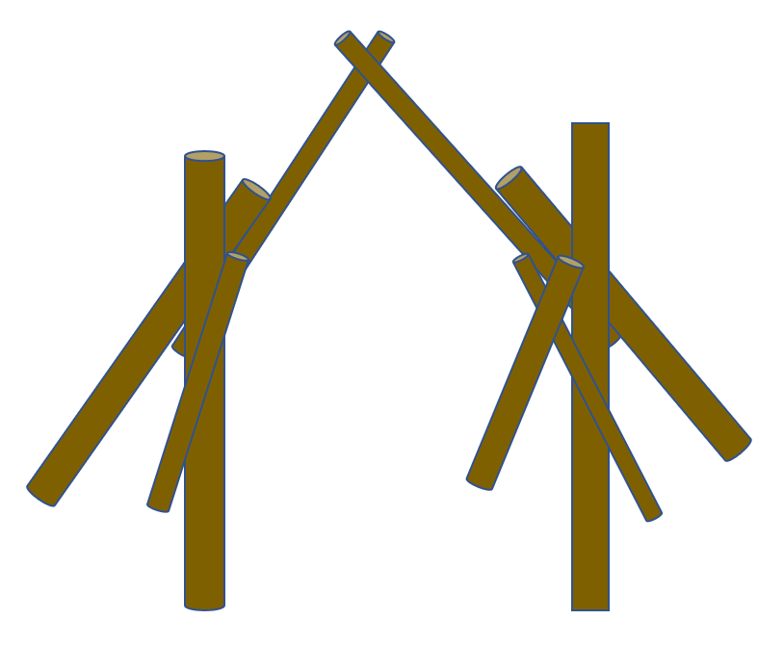
Gateway - Top View
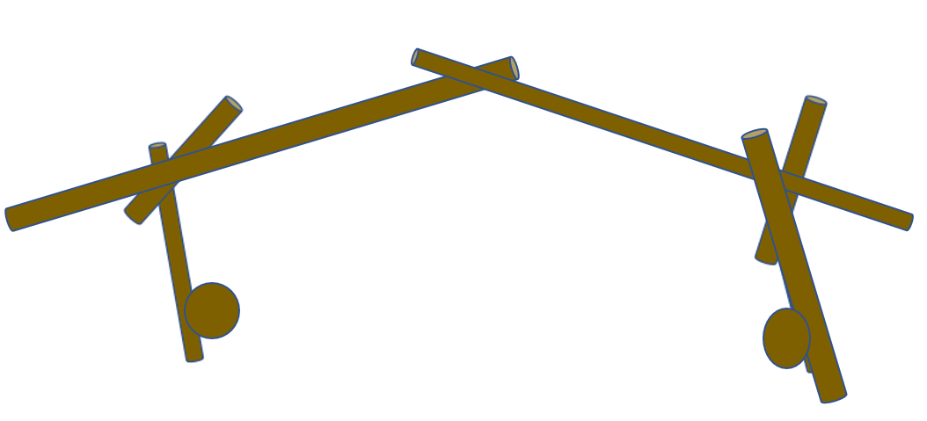

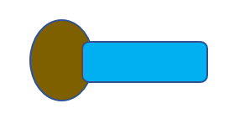
Flagpole - Side View Flagpole - Top View
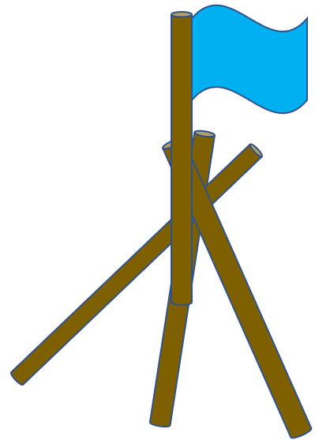

Prep Table - Side View
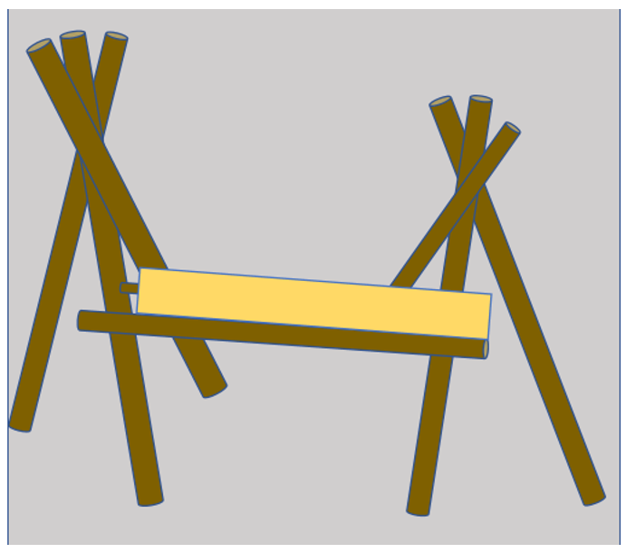

Prep Table - Top View
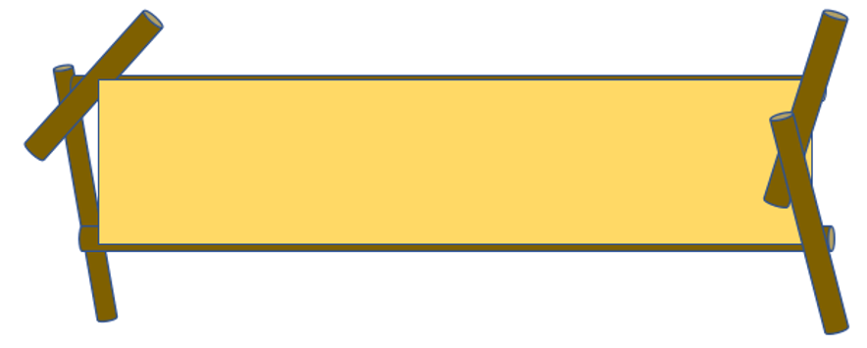


Notie Board - Side View Notice Board - Top View
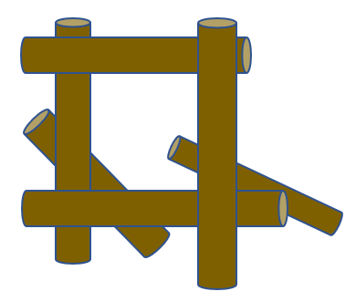
Drying Line - Side View
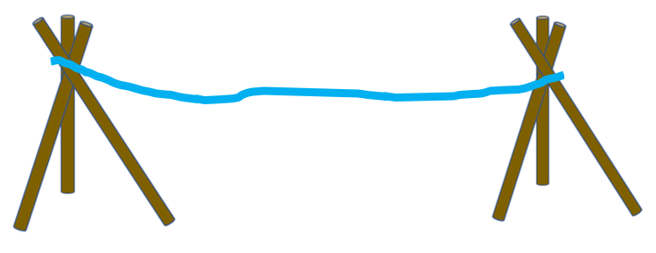
Drying Line - Top View
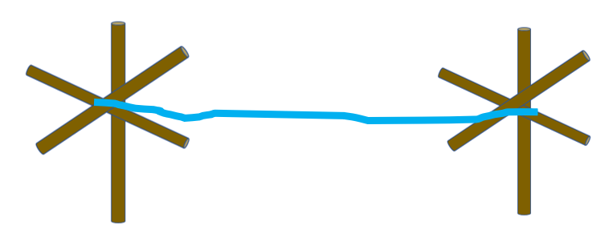

Gadget Construction Instructions

Dining Table

Using 3M Poles build two tripods using a figure of 8/tripod lashing. Using the 3.6M poles join the two tripods at waist height. Check that it is comfortable for seating. At sitting height tie the 1.8m pole across the base of the tripod to create a cross member. Join 2 x 3.6M pole using a shear lashing. Picket both tripods in place. Add the table top and lash with sisal.

Prep Table

Using 3M Poles build two tripods using a figure of 8/tripod lashing. Using the 3.6M poles join the two tripods at waist height. Check that it is comfortable for standing and working. Picket both tripods. Add the table top and lash with sisal.

Airing/Drying line

Using 2.8M Poles build four tripods using a figure of 8/tripod lashing. Picket each tripod and join them with two 10M Ropes.

Gateway

Using 3M Poles build two tripods using a figure of 8/tripod lashing. Join the two tripods with 2 3m staves and mount the sign. Picket the gateway in place. Tie a “North Pole” to the top of the gateway. Decoratively weave string.

Dustbin

Using 2.4m poles build a tripod using a figure of 8/tripod lashing. Using sisal create a dustbin receptacle. Peg the gadget down.

Wash Stands

Using 2.4m poles build a tripod using a figure of 8/tripod lashing. Using sisal create a wash bowl receptacle. Peg the gadget down. Add a 2 x washing bowls plus soap.

Flagpole

Using 3M Poles build one tripod using a figure of 8/tripod lashing. Shear lash the longer 3.6 pole to the tripod and create a floating anchor between the legs of the tripod. Picket the flag pole to the ground.

Notice Board

Using Square lashing, tie the orange 2m poles into a square. Add support structures to the frame so it can rest on the ground at a 45” angle. Peg down the notice board and mount the board using sisal.

Gadget Equipment List

Dining Table
●6X 3m Poles (Red)
●6X 3,6m Poles (Blue)
●2X 1,8m Poles (Green)
●1X Table Top (Board)
●22X Ropes
●2X Pickets

Prep/Washing Table
●6X 3m Poles (Red)
●2X 3,6m Poles (Blue)
●4X 1,2m Staves (Orange)
●1X Tabletop (Board)
●26X Ropes
●2X Pickets

Airing/Drying Line
●12X 2,4m Staves (Yellow)
●4X 1,2m Staves (Orange)
●20X Ropes
●4X 13m Ropes (Red)
●8X Pickets

Gateway
●6X 3m Poles (Red)
●2X 3m Staves (Red)
●2X 2,4m Poles (Yellow)
●2X 3,6m Poles (Blue)
●1X 3,6m Staves (Blue)
●20X Ropes
●4X 13m Ropes (Red)
●2X Pickets
●4X Storm Pegs

Dustbin (3X)
●9X 2,4m Staves (Yellow)
●3X Ropes

Wash Stand (2x)
●6X 2,4m Staves (Yellow)
●6X Ropes
●2X Wash bowls

Flagpole
●1X 3,6m Stave (Blue)
●3X 2,4m Staves (Yellow)
●6X Ropes
●4X 13m Ropes (Red)
●3X Picket
●4X Storm Pegs
●1X Pulley
●1X Sical Ball

Notice Board
●6X 1,2m Staves (Orange)
●6X Ropes
●1X Number Board

Camp Site Layout

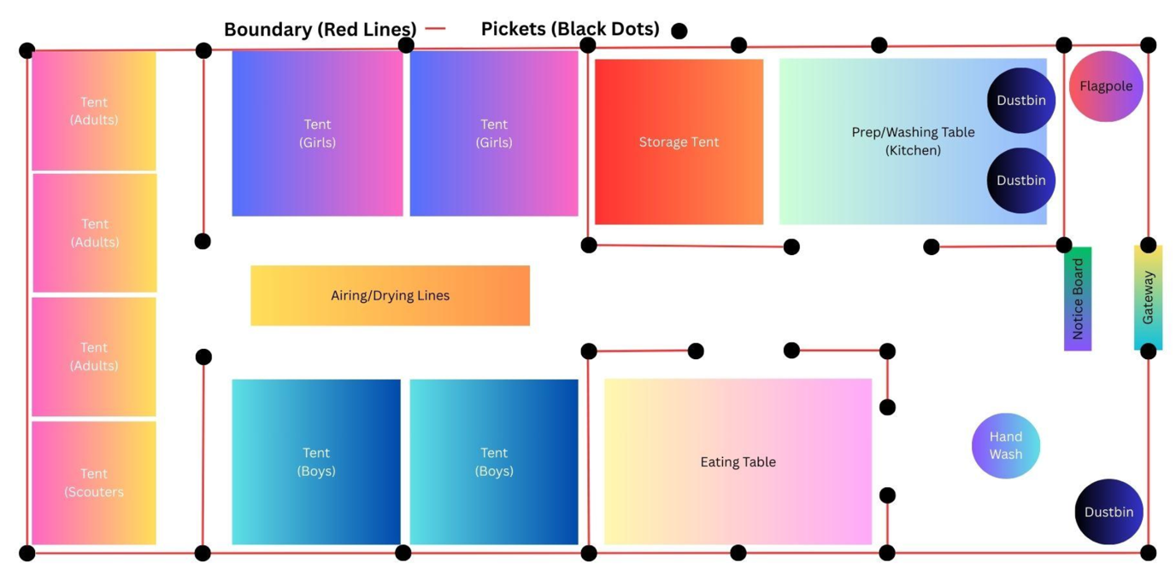
Scale 1:15

Camp Setup Instructions

General Setup Notes

- Use long rope for boundary lines and secure with pickets at each corner and key points as marked.
- All gadgets and tents must be securely picketed for safety and wind resistance.
- Ensure clear walkways between each zone.
- Set up in the order listed below for maximum efficiency.

1. Boundary and Picket Setup

- Begin by laying out the full camp boundary using line rope as per diagram.
- Insert pickets at regular positions. Ensure corners are square and boundaries taut.

2. Tent Area Setup

Left Side – Adult/Scouter Tent Zone

- Erect adult tents at the back of the campsite as required.
- Place the scouter tent nearest the scout tents

Top Centre – Girls Tent Area

- Erect the Girls’ Tents side by side as per layout.
- Insert the poles in the clips
- Raise the tent and clip the poles into the clips
- Place the fly sheet over the tent
- Peg the tents down on all corners

Bottom Centre – Boys Tent Area

- Erect two Boys’ Tents side by side directly below the Airing/Drying Line.
- Insert the poles in the clips
- Raise the tent and clip the poles into the clips
- Place the fly sheet over the tent
- Peg the tents down on all corners

3. Storage and Kitchen Zone

Storage Tent

- Set up directly right of the girls’ tents.
- Ensure a clear space between tent and kitchen.
- Insert the poles in the clips
- Raise the tent and clip the poles into the clips
- Place the fly sheet over the tent
- Peg the tents down on all corners

Prep/Washing Table (Kitchen Area)

- Erect just right of the Storage Tent.
- See gadget instruction
- Include wash basins and prep space.
- Place 2 Dustbins in front-right corner of the Kitchen area for waste.

4. Eating & Airing Areas

Eating Table

- Place in the bottom-right of the main boundary.
- See gadget instructions
- Ensure all sides are accessible and positioned near the Boys' tents.

Airing/Drying Line

- Set up centrally between Girls’ and Boys’ tents.
- Use 4 tripods with two 10m ropes stretched across.

5. Entry

Gateway

- Construct gateway at the far-right opening.
- Use two tripods with cross poles and mount the group sign + number board.
- See gadget instructions

Notice Board

- Set up just inside the gateway, on the left side of the path.
- See gadget instructions

Flagpole

- Place right next to the top-right corner inside the gateway as per layout diagram
- Ensure upright stability and clear visibility.
- See gadget instructions

6. Utility and Sanitation

Hand Wash Station

- Position slightly outside the kitchen/eating zone on the lower right area.
- See gadget instructions

Third Dustbin

- Place this in the bottom-right corner of the entire campsite area.
- See gadget instructions

Camp Site Equipment List

General

Scout Kit List

Kit List for Kontiki 2025
NB: please label everything
Full uniform for opening and closing parade
Coat hanger (to hang uniform)
Camp uniform – black shirts, jeans and comfortable shoes
Rain Jacket and gumboots
Warm gloves, beanies, socks
Warm clothes
Change of clothes
Hats and sunscreen
Working gloves
Sleeping bag, pillow and extra blanket (if necessary)
Sleeping mat
Mess kit (plate, bowl, mug, cutlery, dishcloth in a bag)
Hand and head torch
Water bottle
Toiletries & insect repellent
Towel (if necessary)
Medication (with instructions if necessary)
Money for tuck shop
Own snacks - recommended

Supporters Catering Menu

Friday Night – Lasagna and Salad
Saturday Breakfast – Oats, Fruit, Boiled Eggs
Saturday Lunch – Hamburgers
Saturday Supper – Spaghetti Bolonaise, Salad Starter, Strawberries and Cream.
Sunday Breakfast – Oats, Beans on Toast.
Sunday Lunch – Chicken Mayonnaise

Catering Budget and Shopping List

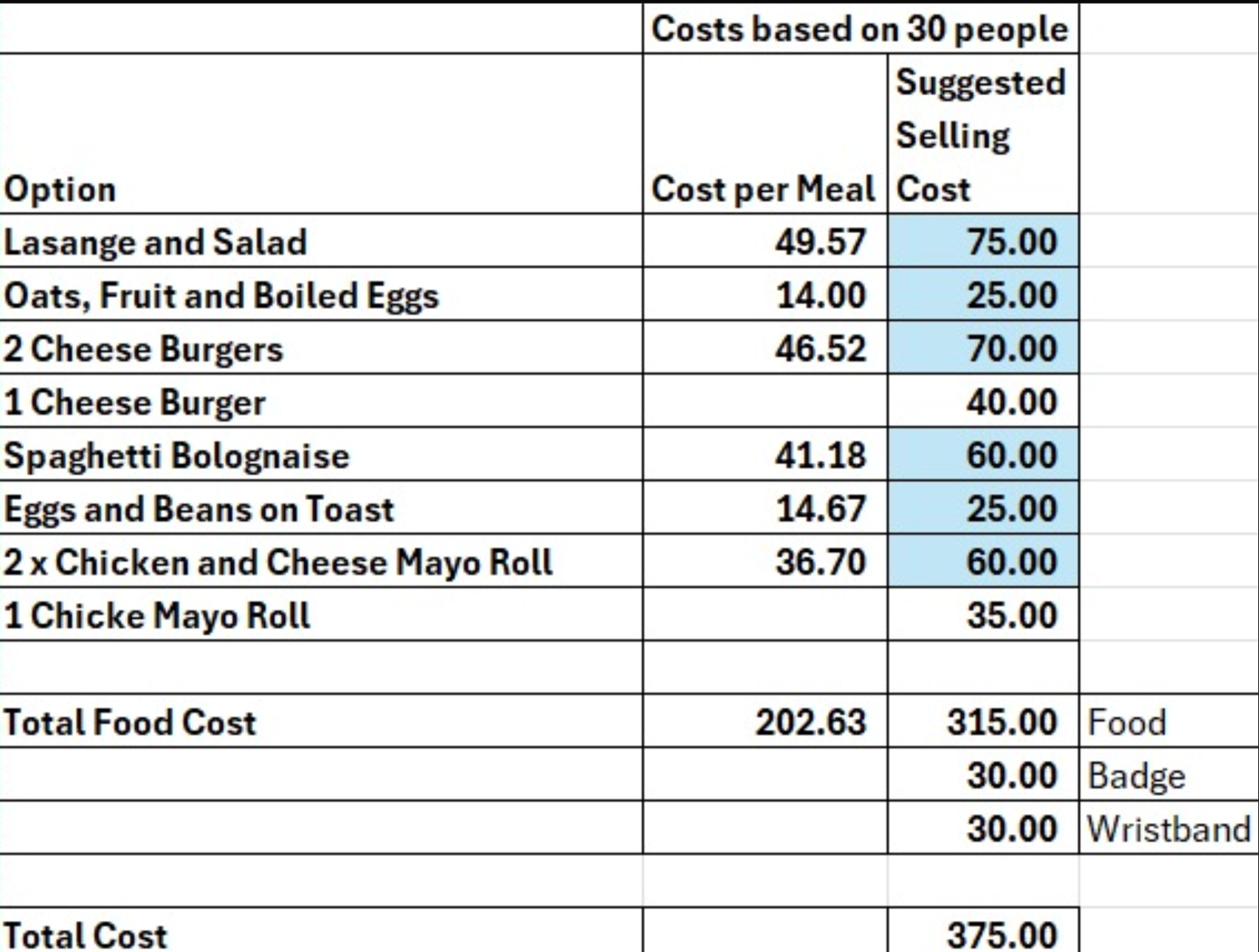

Shopping List

Lasagne Pasta X 8 boxes
Mince X 12kg
Salt X 375g
Garlic Clove x 2
Flour 2kg
Lettuce x 4
Cucumber x 3
Tomato x 12
Feta Cheese x 1
Olive Jar x 1
Mayonnaise 500G x 6
Oats x 1kg
Eggs x 60 Large
Oil x 1L
Milk x 16L
Hamburger Buns x 120
Hamburger Patties x 60
Spaghetti Pasta x 8 packets
Bolonaise Sauce x 4
Strawberries x 4 punnets
Cream x 2L
Brown Sugar x 2kg
Sugat x 2 kg
Bread x 6 loafs
Baked Beans x 24 Cans
Chicken Breasts x 36
Rusks x 6 packets
Chips x 12 packets
Oros x 6L
Coffee x 2kg
Tea x 100bags
Hot Chocolate x 2kg

Kontiki Camp Budget

Budget based on

24 Scouts @ R 400 per scout camping
6 Adults @ R 400 per scout camping
16 Adults @ R 200 helping various days plus extra food

 |  | Tent Repair | 0
 |  | Rope | 1200
 |  | Fire Extinguishers | 410
 |  | First Aid | 400
 |  | Gas | 300
 |  | Ammo Boxes | 1920
 |  | Food | 8000
 |  | Camp Fees | 4320
Camp Fees | 13200 | Total Costs | 16550
Fund Raising | 3800

Supporters Meal Recipes

Spaghetti Bolognese

Ingredients
- 2 tbsp olive oil
- 400g/14oz beef mince
- 1 onion, diced
- 2 garlic cloves, chopped
- 100g/3½oz carrot, grated
- 2 x 400g tins chopped tomatoes
- 400ml/14fl oz stock (made from stock cube. Ideally beef, but any will do)
- 400g/14oz dried spaghetti
- Salt and pepper

Method
- Heat a large saucepan over a medium heat. Add a tablespoon of olive oil and once hot add the beef mince and a pinch of salt and pepper. Cook the mince until well browned over a medium-high heat (be careful not to burn the mince. It just needs to be a dark brown colour). Once browned, transfer the mince to a bowl and set aside.
- Add another tablespoon of oil to the saucepan you browned the mince in and turn the heat to medium. Add the onions and a pinch of salt and fry gently for 5-6 minutes, or until softened and translucent. Add the garlic and cook for another 2 minutes. Add the grated carrot then pour the mince and any juices in the bowl back into the saucepan.
- Add the tomatoes to the pan and stir well to mix. Pour in the stock, bring to a simmer and then reduce the temperature to simmer gently for 45 minutes, or until the sauce is thick and rich. Taste and adjust the seasoning as necessary.
- When ready to cook the spaghetti, heat a large saucepan of water and add a pinch of salt. Cook according to the packet instructions. Once the spaghetti is cooked through, drain and add to the pan with the bolognese sauce. Mix well and serve.
- Add Parmesan Cheese to taste

Green Salad

Ingredients
- ½ small red onion, thinly sliced
- 2 large ripe tomatoes, roughly chopped
- ½ cucumber, deseeded and roughly chopped
- 100g/3½oz reduced fat feta cheese, drained and cut into cubes
- 50g/1¾oz black olives, pitted and drained (in brine not oil and preferably Kalamata olives)
- small handful fresh mint leaves
- ½ tsp dried oregano
- 2 tsp extra virgin olive oil
- 2 tsp fresh lemon juice
- sea salt and freshly ground black pepper
- 2 wholemeal pitta breads, warmed

Method
- Put the onion, tomatoes and cucumber in a bowl and season to taste.
- Scatter the feta, olives and mint leaves on top. Sprinkle over the oregano and toss lightly. Drizzle over the oil and lemon juice and serve with warmed pitta bread.

Strawberries and Cream

Ingredients
- 350g/12oz caster sugar
- 300ml/½ pint clotted cream
- 900g/2lb fresh small strawberries

Method
- Slice strawberries in half and clean the ends
- Whip clotted cream until stiff
- Sprinkle cream with sugar
- Serve with the clotted cream and strawberries

